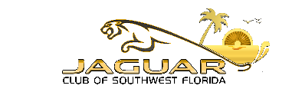
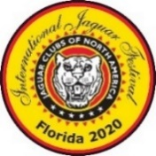

Registration Form JCNA International Jaguar Festival 2020 Fort Myers, Florida WEDNESDAY, OCTOBER 20 – SUNDAY, October 24, 2021 Go to http://marriott.com/rswsb for hotel reservations. Hotel direct number 239-466-4000
Name/s: ________________________________________ Address: __________________________________
City: ______________________________ State: __________________________ Zip Code: _______________
JCNA Number: _____________ JCNA Club: _____________________ Region: ___________________________
Primary Phone: ______________ Mobil Phone: _______________ Email: _____________________________
OCTOBER 20, WEDNESDAY PRICE PERSONS $ TOTAL
Breakfast on your own
Lunch N/C ( ) N/C
REVS World Renown Automobile Museum Tour $40.00 pp ( ) $__________
Marriott Princess Dinner Cruise limited Space $75.00 pp ( ) $__________
OCTOBER 21, THURSDAY
Breakfast on your own
Rally - Lunch Included - (Jaguar Ft. Myers Dealership as your host) $35.00 pp ( ) $___________
Scenic Tour - Lunch Included – (Jaguar Ft. Myers Dealership as your host) $35.00 pcar ( ) $ __________
Welcome Reception Marriott in the Island Room Hors d’Oeuvres N/C ( ) N/C
Dinner on your own. (List of restaurants in your concours packet).
OCTOBER 22, FRIDAY “On the Green” IJF Concours d’Elegance Registration
1st Car: Model: ___________________ Style: _______________ Year: _________ Class: ________________
2nd Car: Model: __________________ Style: _______________ Year: _________ Class: ________________
Champion $70 ___ 2nd Car $40 ___ Driven $70___ Special $70 ___ Display $35 ____ $ _________
I am a CURRENT Certified JCNA Judge and available to judge at the IJF – YES NO (please circle one)
Class/s that you would like to judge ____________________________________________________________
Concours Awards Dinner in the Garden Ballroom - $85.00 pp ( ) $_________
OCTOBER 23, SATURDAY
Breakfast on your own
Slalom (Helmet Required) Lunch Included $40.00 pcar ( ) $________
Model:_____________ Year: _________ JCNA Class: ____________
Slalom & Rally Award Dinner (Marriott Poolside) $65.00 pp ( ) $_________
October 24, SUNDAY
Farewell Breakfast & Awards Marriott in the Veranda Room N/C ( ) N/C
Total amount $ ______________
For information contact Phil Mannino (407)312-0218 or philmannino2@gmail.com Go to jaguarclubofswf.com to register on-line or pay by check to JAGUAR CLUB OF SWF, mail to Phil Mannino 19831 Quisto St, Venice, Florida 34293

Signature: ____________________________________________________________

